PRACTICAL LIST – AY: 2026- 27
Sr. no. | Title
7. | Title: Performance Testing using Apache JMeter  Aim: To analyze application performance under different loads.  Software Required  ● Apache JMeter  ● Java JDK  Procedure  1. Create Test Plan.  2. Add Thread Group.  3. Configure Users.  4. Add HTTP Request.  5. Execute Test.  6. Analyze Reports.  Expected Outcome: Performance metrics are generated.  Result: Performance successfully analyzed.
Solution:
Step-1: Install JDK 8 or above on your system.
Step-2: Download Apache JMeter from the official website.
https://jmeter.apache.org.
Step-3: Extract the downloaded JMeter archive.
Step-4: Launch JMeter by running jmeter.bat on Windows or jmeter.sh on Linux/macOS.
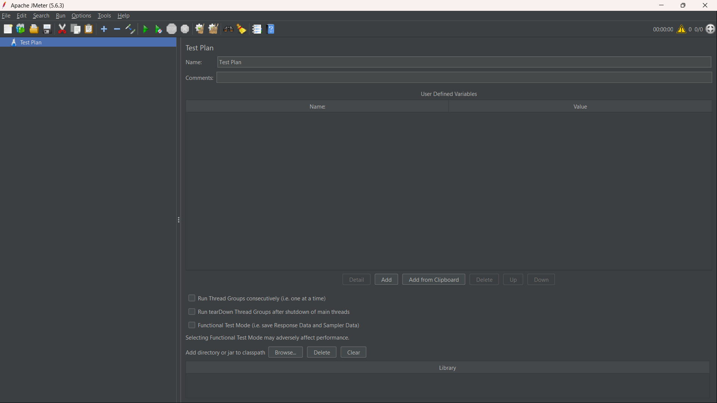
Step-5: Create a Test Plan to define and organize your performance test.
Step-6: Add a Thread Group by selecting Test Plan → Add → Threads (Users) → Thread Group.
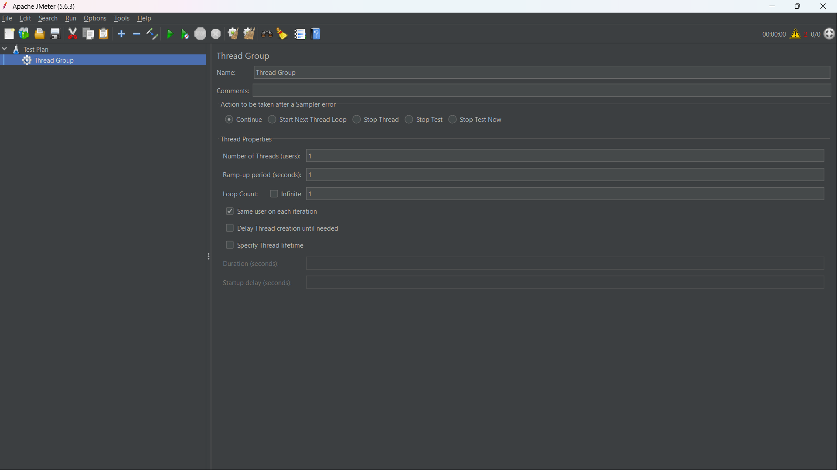
Step-7: Configure the Thread Group by setting the Number of Users, Ramp-Up Period, and Loop Count.
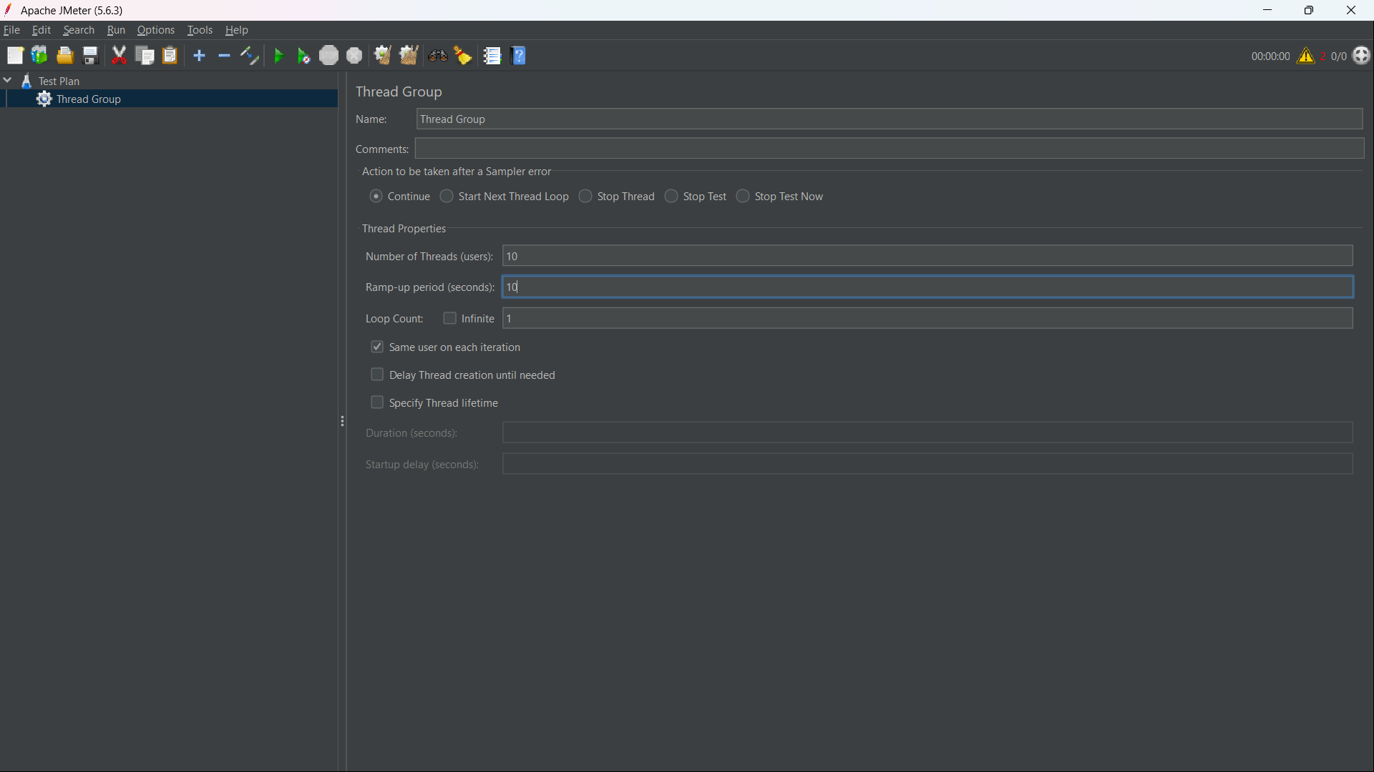
Step-8: Add an HTTP Request Sampler through Thread Group → Add → Sampler → HTTP Request.
Step-9: Configure the HTTP Request with the Protocol, Server Name/IP, Path, and HTTP Method.
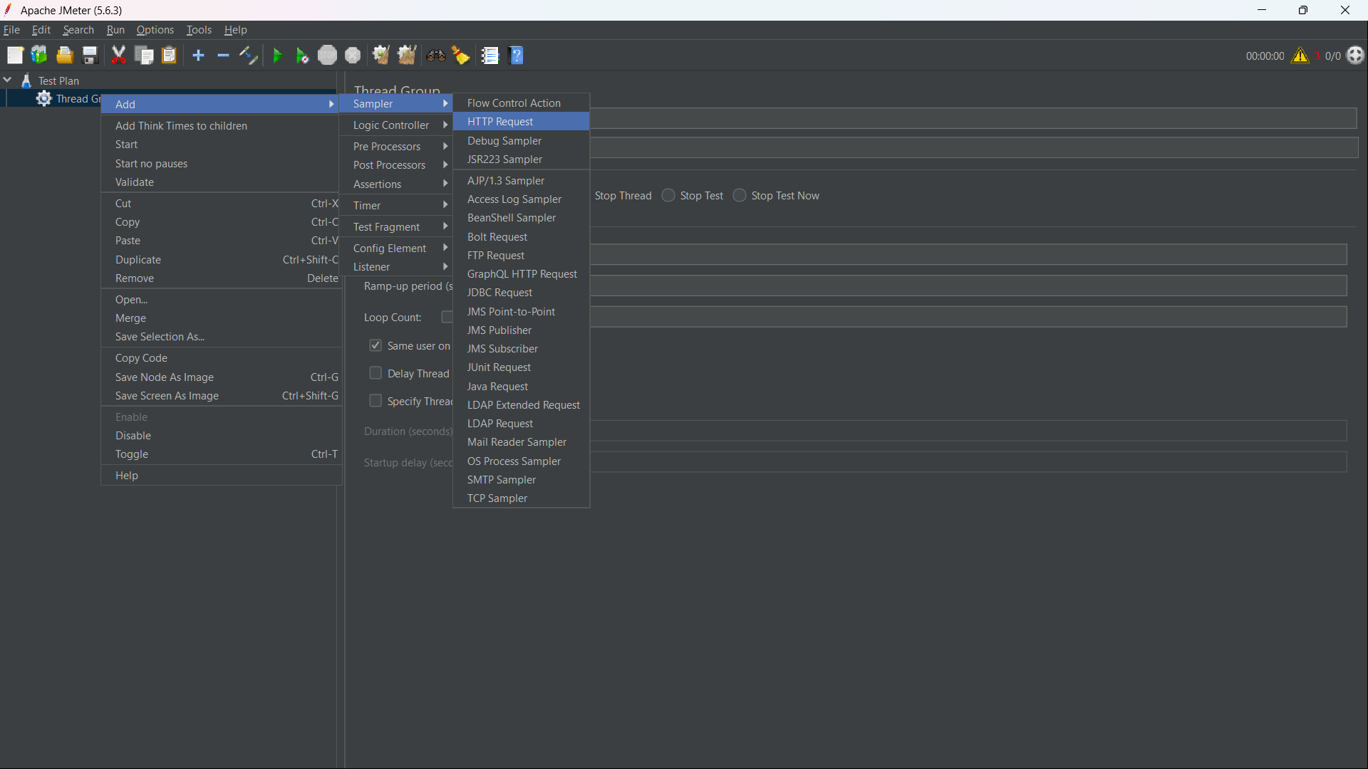
Step-10: Add the required JSON payload under Body Data for POST requests.
Step-11: Add an HTTP Header Manager through Thread Group → Add → Config Element → HTTP Header Manager.
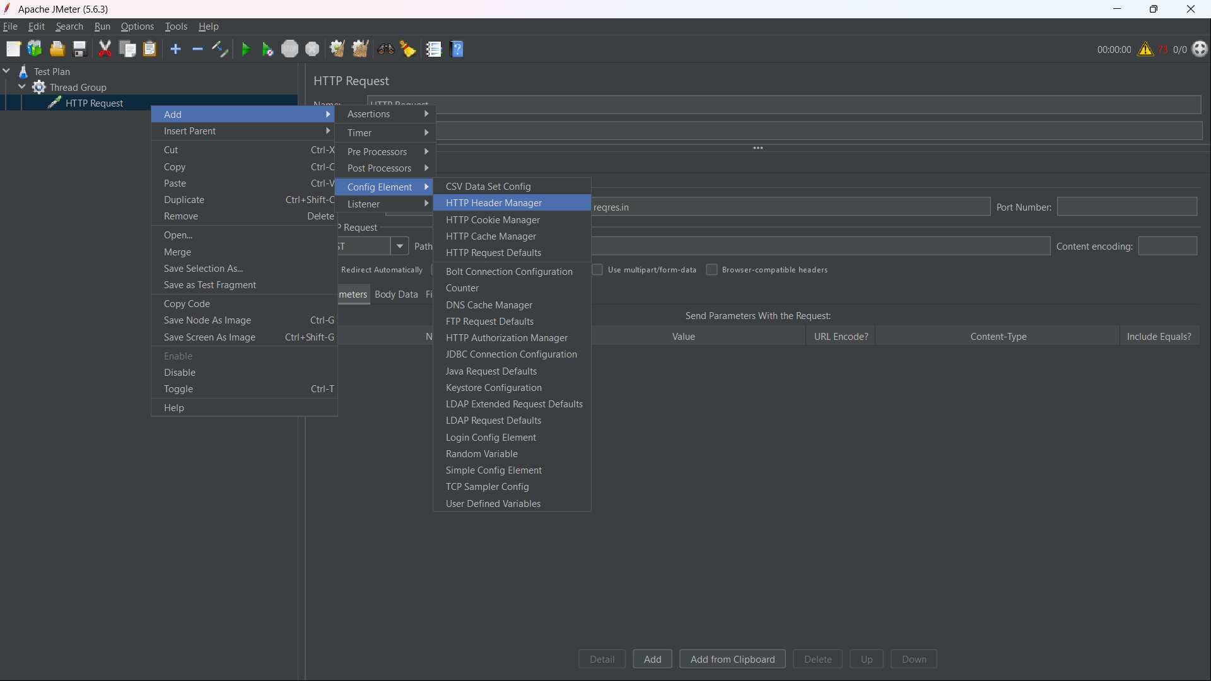
Step-12: Configure the required authorization header, such as x-api-key, with the API token.
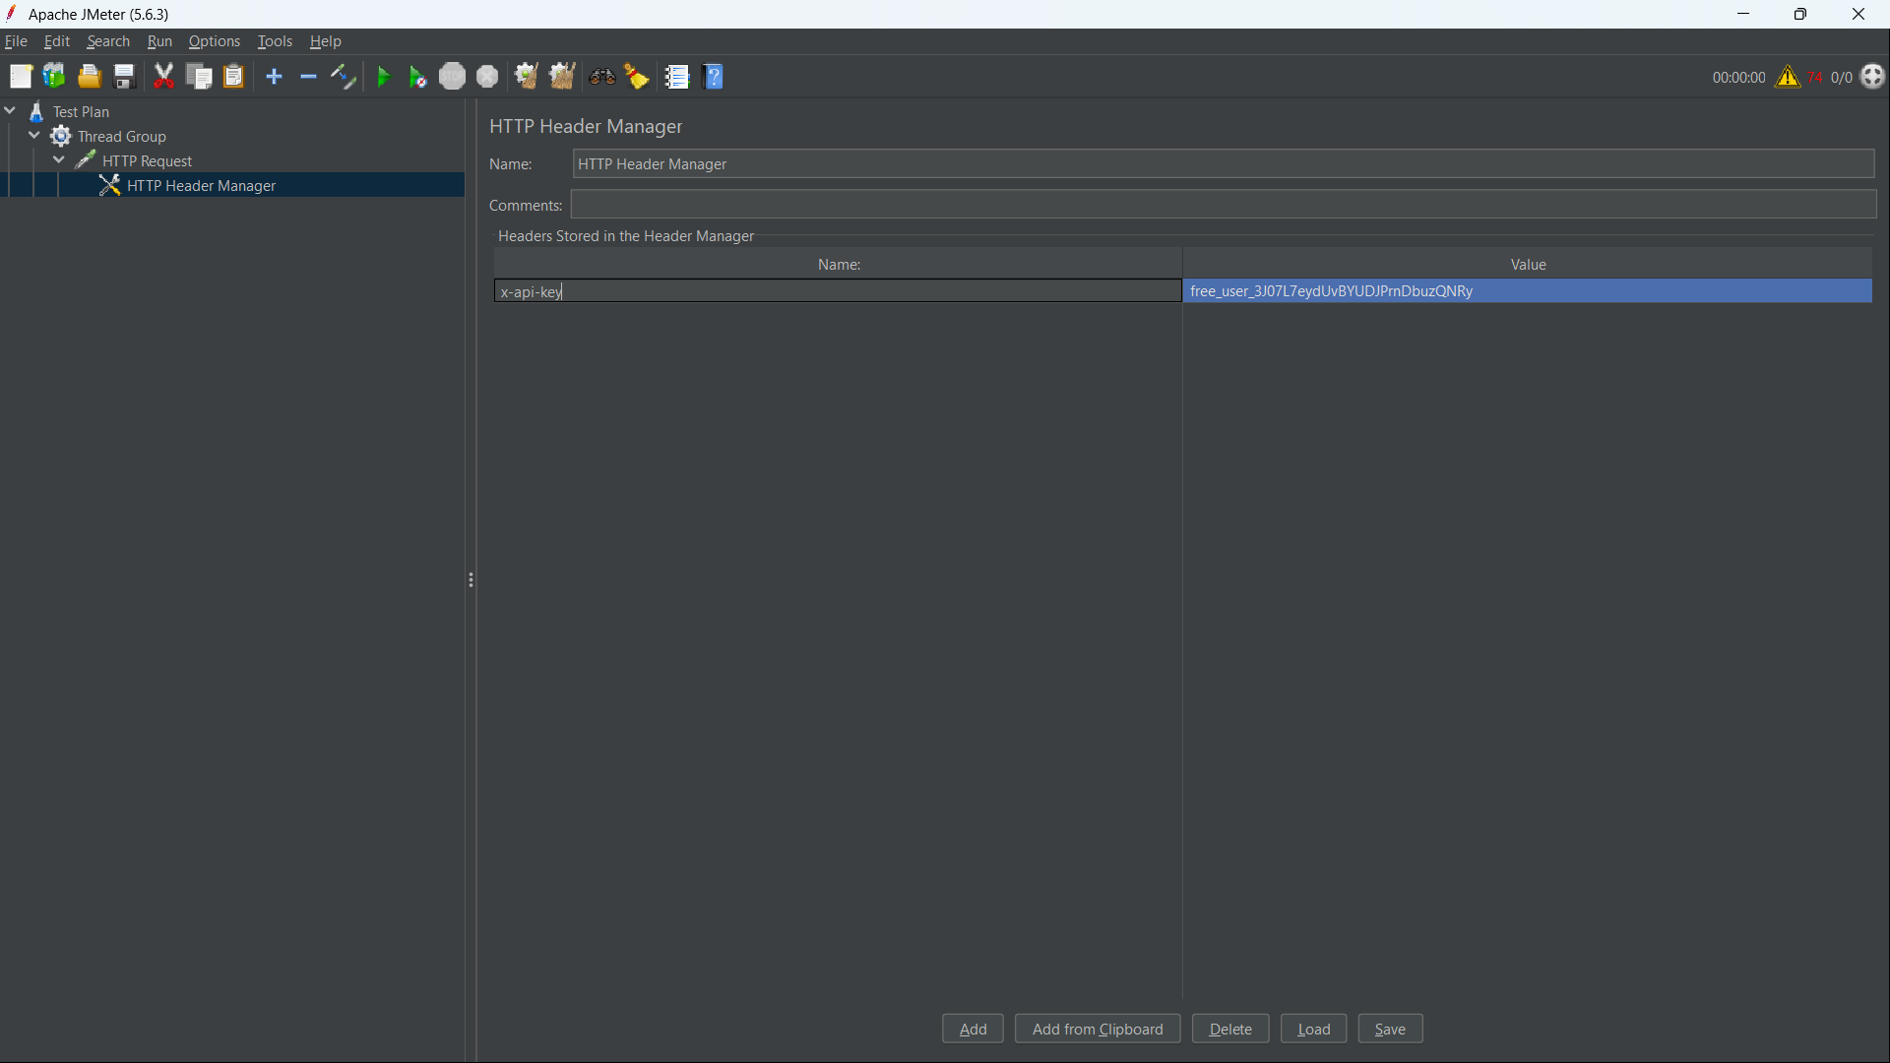

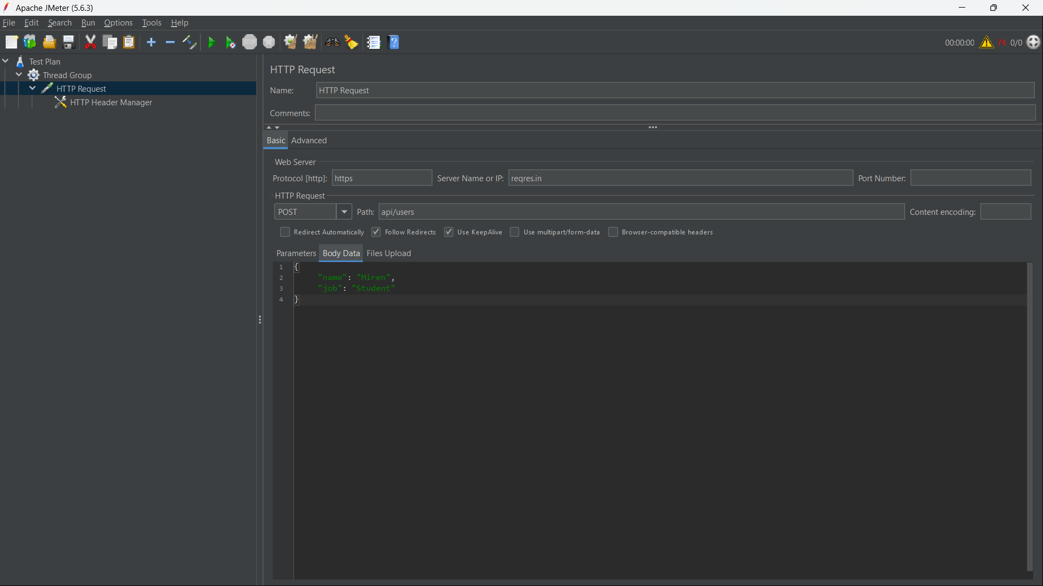
Step-13: Add Listeners such as View Results Tree, Summary Report, or Graph Results to monitor performance.
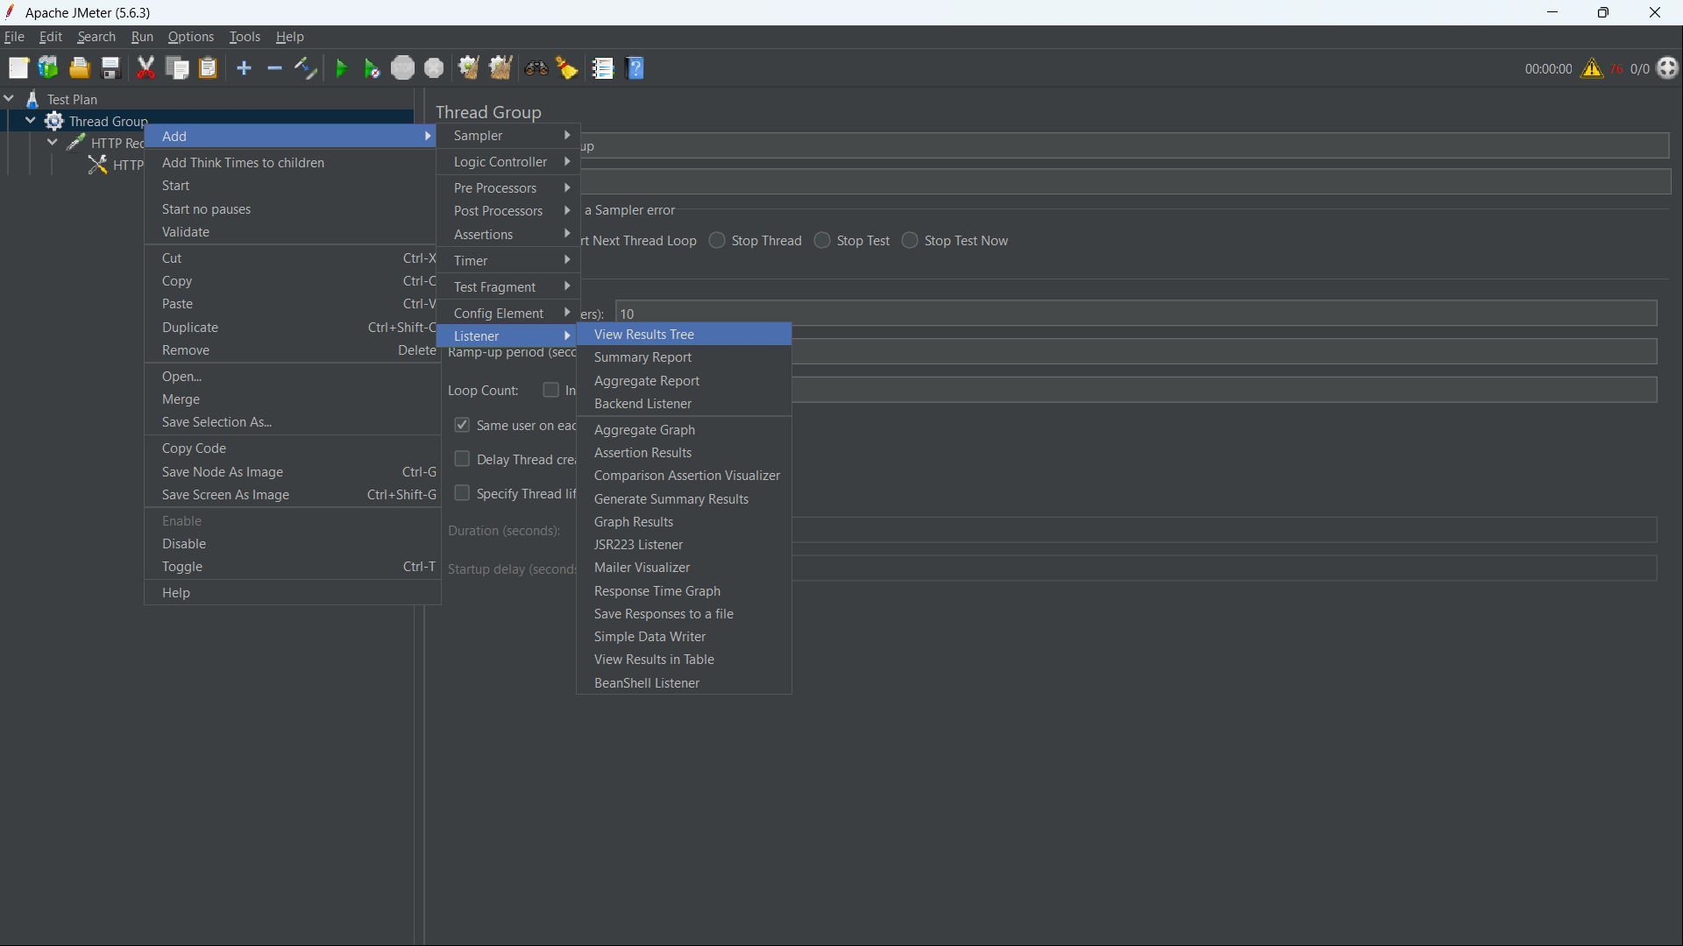
Step-14: Save the configured JMeter Test Plan before starting the test.
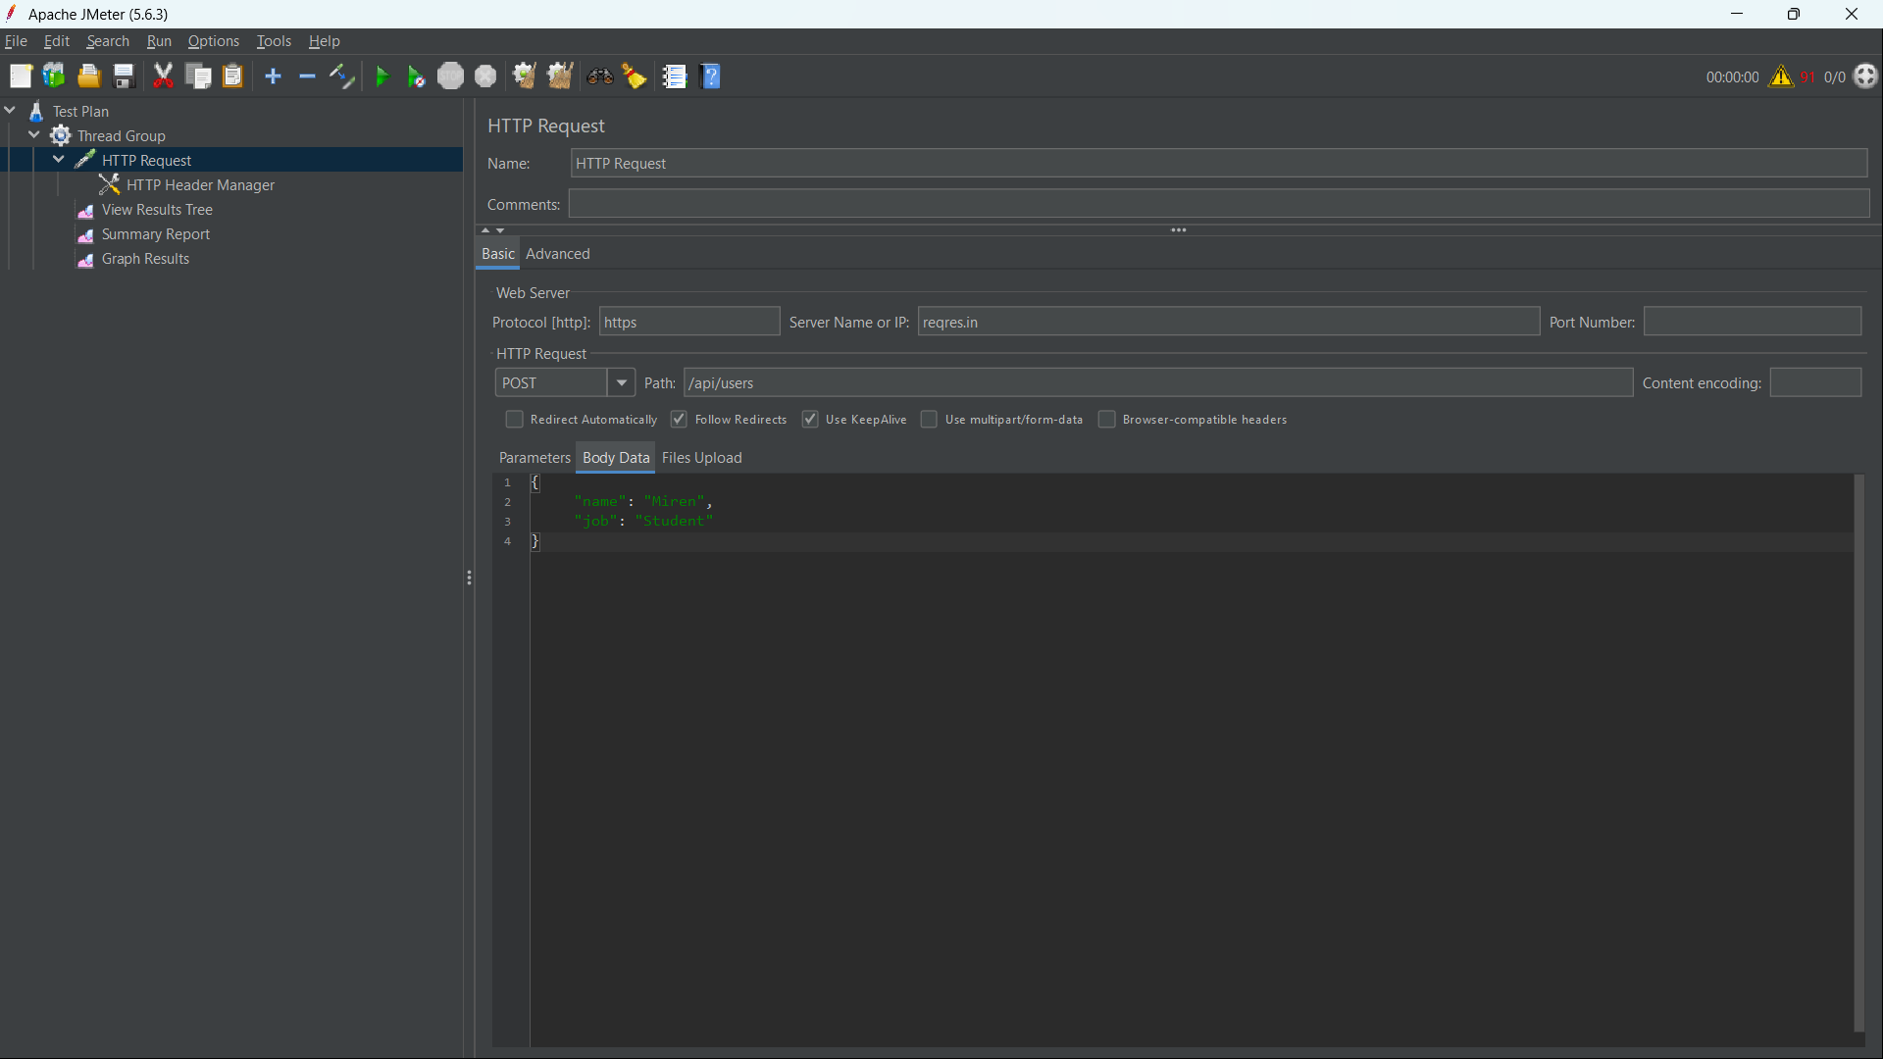
Step-15: Click the green Run button to execute the performance test.

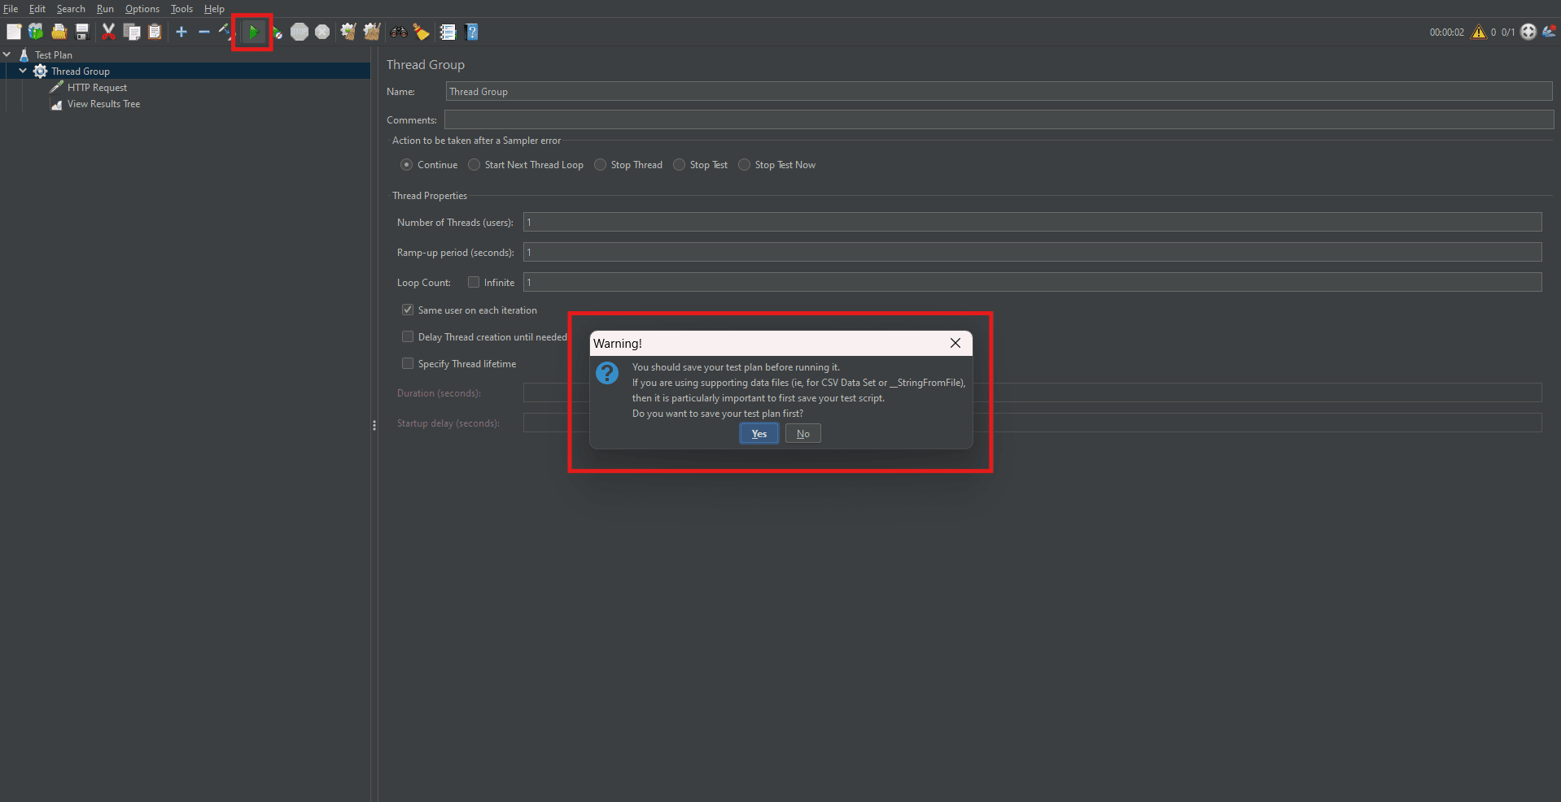

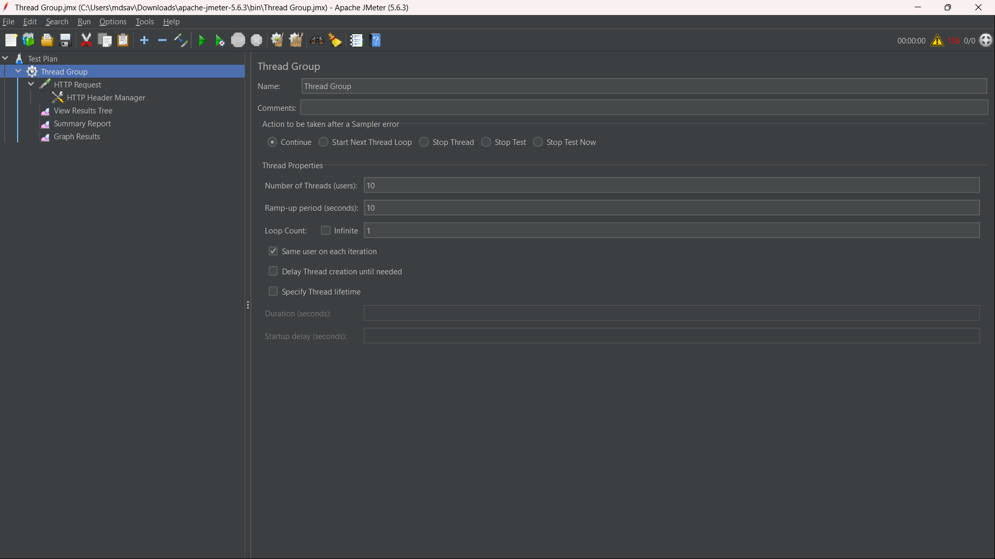
Step-16: Monitor the test execution and results using the configured Listeners.
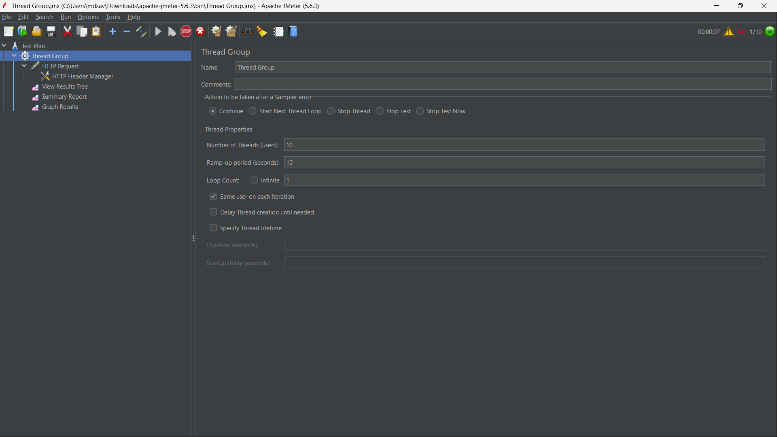
Step-17: Click the Stop button to stop the test after completion.
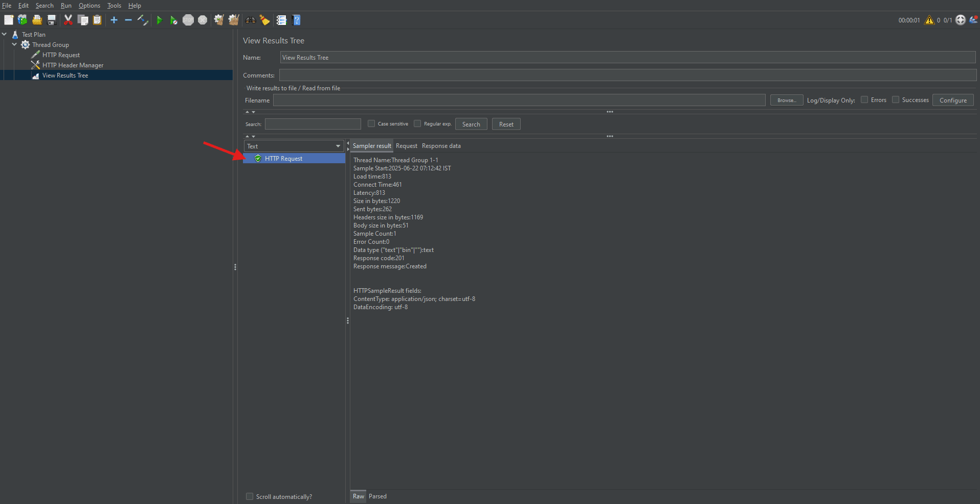
Step-18: Increase the Number of Threads (Users) to simulate multiple concurrent users.
Step-19: Analyze the Average Response Time, Throughput, and Error Percentage in the Summary Report.
Step-20: Save the test results as a .csv file from the Summary or Aggregate Report.
Step-21: Create an output directory such as D:\JMeter_HTML_Report for the HTML report.
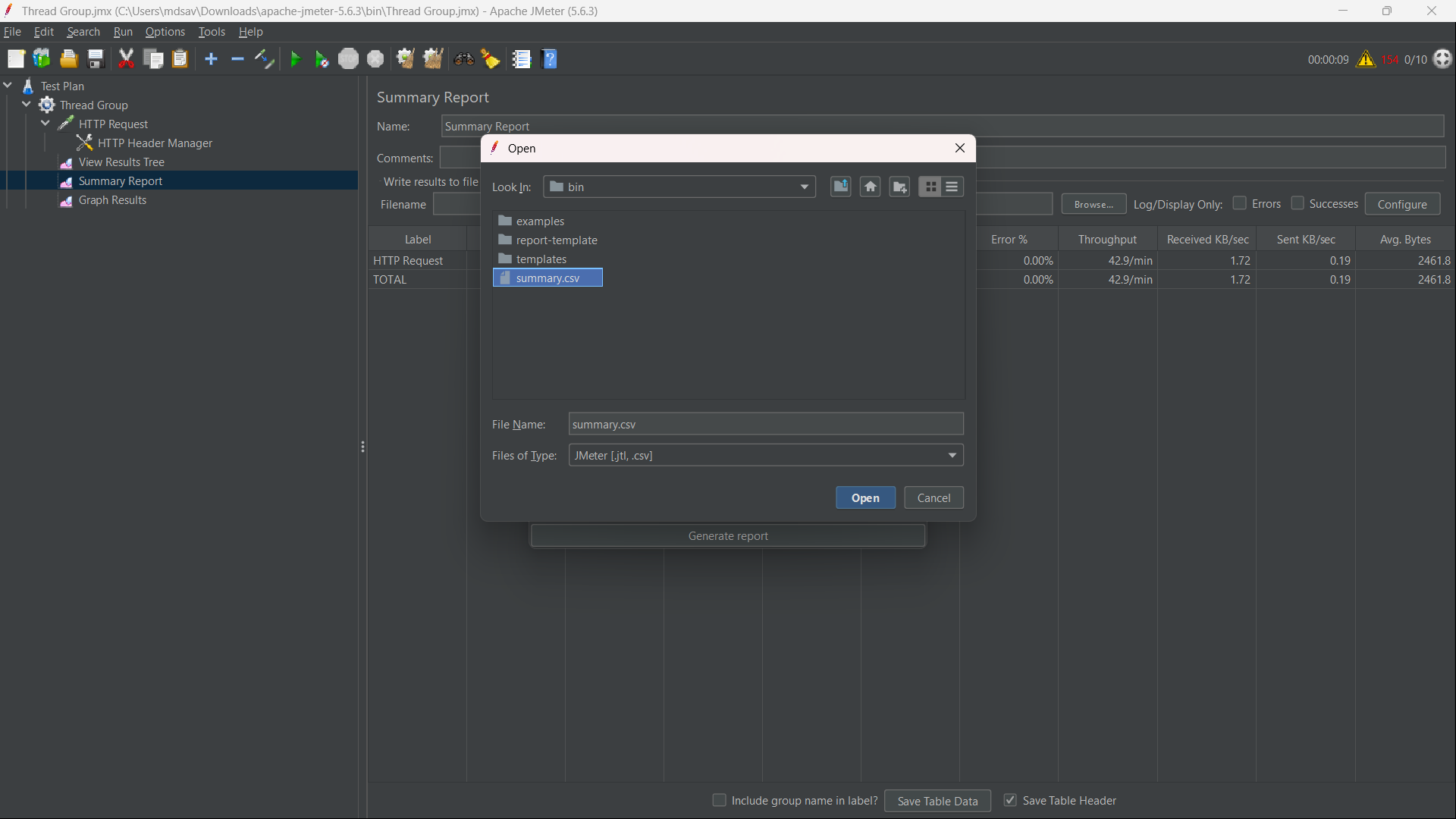
Step-22: Generate the HTML report through Tools → Generate HTML Report using the results file, user.properties, and output directory.

Step-23: Open index.html from the output folder in a browser to view the final performance report.
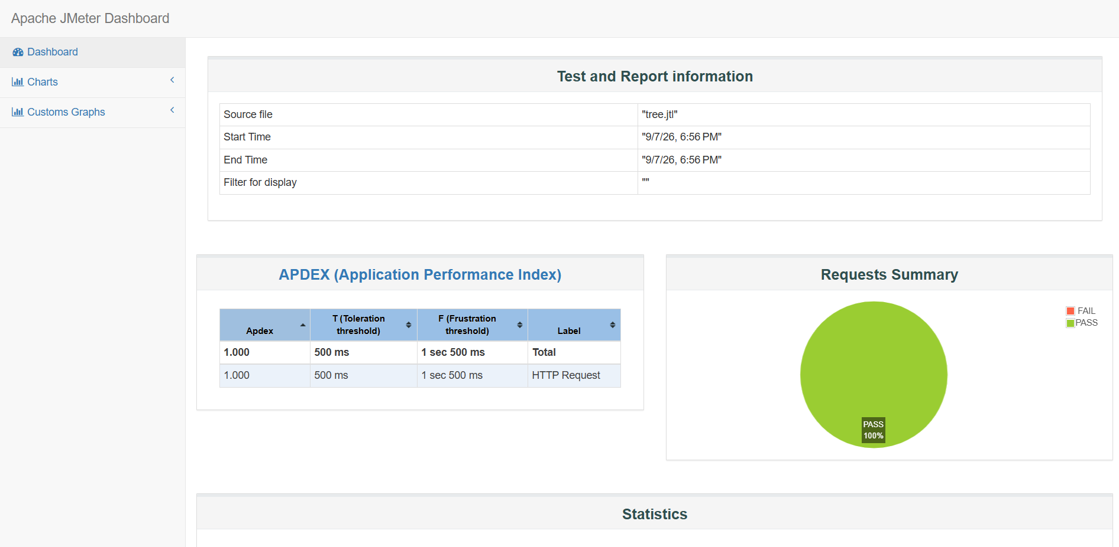
Tutorial | https://www.youtube.com/playlist?list=PLUDwpEzHYYLs33uFHeIJo-6eU92IoiMZ7
s

